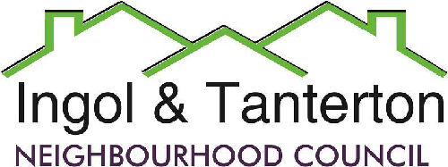
Gill Mason - Clerk and RFO
Email: ingoltantertonnc@hotmail.co.uk

Agenda
A meeting of the Ingol and Tanterton Neighbourhood Council Finance & Asset Committee will be held on Wednesday 19th June 2024 at 6.30pm at Tanterton Village Centre.

Open forum

1.To receive apologies.

2.To approve the minutes of the February Finance Committee Meeting.

3.To consider and approve the purchase of the clerk’s laptop.

4.To complete a mini audit of accounts and review the performance against budget.

5.To consider and approve the costs for the Cottam Lane bridlepath gate.

6.To consider the grant request from the Friends of Ingol Library.

Press and public are welcome to attend.

